19/8/2020

Back to School Logistics Plan

Dear Parents,

We are all looking forward to welcoming our students back into school on Tuesday September 1st. This year has been very unusual and I would like to thank you all for the help and support since March. Our goal from now on is keep our school open. Below are the details of what we have put in place to make our school as safe as possible for our students. We will do as much as we possibly can to minimise the risk but we cannot eliminate it.

Entry/Exit Procedures:

We will use two entry/exit points this year to minimise groups congregating. Children can enter via whichever gate is closest to them. There will be a hand sanitising station at each entrance. Children will be escorted out to the relevant gate by their teacher at the end of the day. No adults are allowed on the school site without prior permission. This is in line with health guidance to minimise the number of people on the grounds. No children are allowed on the school grounds before 8.40am to avoid groups gathering and as they are not covered by insurance. Doors will open at 8.40am and children will go straight to their classrooms. Teaching will start at 9.05am. This will allow 25 minutes for arrival at school so everyone doesn’t have to arrive at the same time. Infants will go home at 1.30pm. 1st to 6th Classes will exit from 2.20pm to 2.30pm as laid out below. Parents cannot gather at the gate so please collect your child and return to your car or leave as quickly as possible. If you need to speak to the teacher please ring Jacinta in the office to arrange a call back or an appointment.

Junior Infants: for the first day JI students start at 9am. Parents can bring their children to the door of the class by the pitch where Ms. Hennessy will bring them into the class. Parents can bring their children in to teacher for the first week until Friday Sept 4th. After this parents will have to drop their children at the gate and leave. From Wed Sept 2nd JI can be dropped into the class from 8.40am to 9.05am when teaching will begin. At the end of the day (1.30pm) JI will be escorted to the gate by the pitch. Please pick up your child and leave as quickly as possible to avoid groups gathering. If you need to speak to the teacher please ring Jacinta in the office to arrange a call back or an appointment.

Senior Infants: Doors open at 8.40am and children will go straight to their class via the door by Room 1. Teaching won’t start until 9.05am so there is no need for everyone to arrive at the same time. SI will exit at 1.30pm by the main gate.
1st Class: children will enter via the door on the yard by Room 5. 1st Class will exit via the gate by the field at 2.30pm.
2nd Class: children will enter via the door on the yard by Room 5. They will exit via the main gate at 2.30pm.
3rd Class: children will enter via the door on the yard by Room 5. They will exit via the main gate at 2.25pm.
4th Class: children will enter via the door by Room 1. They will exit via the main gate at 2.20pm.
5th Class: children will enter via the door by Room 11. They will exit via the gate by the pitch at 2.20pm.
6th Class: children will enter via the door by Room 11. They will exit via the gate by the pitch at 2.25pm.

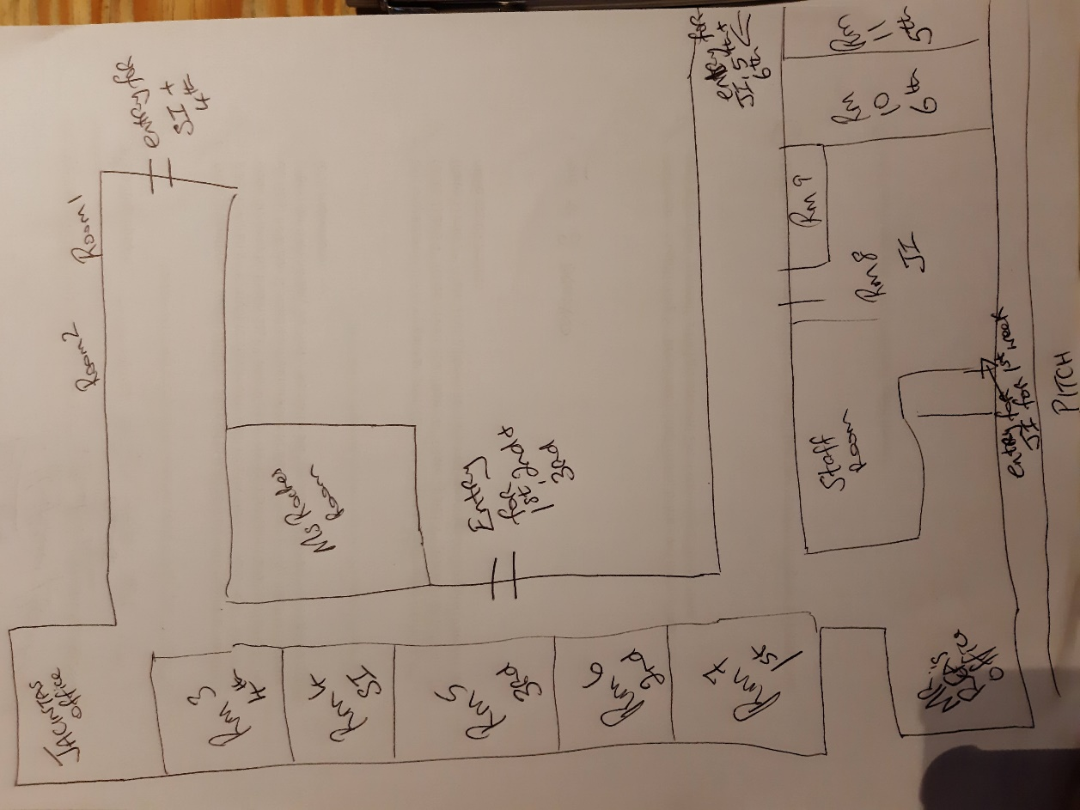

Uniforms:
Children are to wear uniform to school and tracksuit on PE days.

Coats:
Children will need coats as we are encouraged to get children out of the classroom often.

Books and equipment:
Children will have their own books and equipment. Some resources in school have to be shared. Children will wash their hands after using shared equipment.

Break Time:
Break times will continue as normal though they will take longer as everyone has to wash their hands before eating and again after break. Each class will have their own space on yard as class groups cannot mix. Exercise and activity will be encouraged.

Covid etiquette:
As I’m sure you have been doing at home we will be reminding our students of good etiquette to stay safe. There is hand soap and hand towels in each classroom and bathroom. There are hand sanitiser dispensers at the entrance of each classroom and entry point to the school.

Class Set Up:
Each class will operate in their own bubble this year and won’t be mixing with other classes.3rd to 6th classes will be further split into pods within their class bubble. Each pod will be 1m from other pods in their class. This does not apply to JI to 2nd Class. Our goal is to minimise mixing and contact as far as possible. We will explain to the children how all of this works when they are in class. Children should not be stressed about who is in what pod as it will operate in a similar way to groups in class every other year.

Staffing:
Our team this year is as follows:
SEN Team: Gillian Diamond (Deputy Principal), Valerie McGrath and Audrey Roche.
Junior Infants: Miriam Hennessy
Senior Infants: Brigid O’Donovan (Sarah Buckley for the month of September)
1st Class: Nuala Murray
2nd Class: Gillian Daly/Niamh Cameron (job share)
3rd Class: Ciara Ryan
4th Class: Estelle Cassidy/Julie Neville (job share)
5th Class: Susan Lynch
6th Class: Louise Morgan

SNAs; Siobhán Collins, Mary Clifford and Aoife Glavin
Secretary: Jacinta Flannery
Caretaker: Mick Glavin

Covid Procedures:
If a child displays any Covid symptoms they will be moved to an isolation area. parents will be contacted and asked to bring the child home and to seek advice from their GP. If there is a positive diagnosis we will be informed by the HSE and we will take advice from them. We are not medical professionals so we will make the best decisions we can in the best interests of everyone in the school. We cannot risk the whole school being shut down by not acting. It is essential that you have arrangements in place if your child has to be collected.
If you or your child are displaying any symptoms at home you cannot come to school.

Staff Absences:
Children cannot be split up among other classes this year. If a teacher is absent we will try to get a substitute in their place. If that fails one of our SEN team or myself will take the class. If this isn’t an option we may have to send the class home. This is a last resort but you need to be aware that it could happen.

Collection/Drop off during the school day:
All collection and drop offs once school has started will be through Jacinta’s office only. The child be brought to/from reception by a member of staff.

Dropping off items during the day:
Please drop the item into reception with your child’s name on it and we will arrange for it to be brought to their class.

Supporting Children who Cannot Attend School:
Please speak to Mr. Rea about this.

Special Education:
We will have to operate a different system this year as we need to minimise the number of people in each class. As we haven’t seen the children in a long time we will have to do some testing to make sure that we target our available resources properly. In so far as is possible one SEN teacher will work with each class based on the needs of this class. Department of Education guidelines mean that SEN teachers will be used to cover mainstream classes when the teacher is out so this will lead to disprution of our SEN provision this year.

Curriculum and Homework:
It will take us all quite a while to adjust to the new rules of engagement in school. Hand washing alone will take a huge amount of time: 24 children will take 12-15mins each time they wash their hands and we will do that at least 5 times a days. That adds up to an hour out of the day. We will focus on the basics and on getting children back into a comfortable and safe routine.
Homework is part of the normal routine and each teacher will explain how it will work in their class. We will use Google Classroom for some assignments so that if we have to go back to remote learning we will all be prepared and have any problems ironed out.

If you have any questions or concerns please speak to us. We want you and your child to feel safe, happy and comfortable.

All the best,

Micheál Rea

