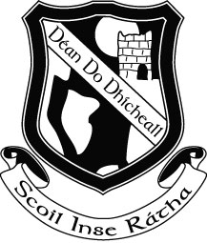

Rang a Se - Sixth Class
Book List 2015 -2016

Religion: My Confirmation Year (Veritas)

English: Treasury F –Core Skills in English (Folens)
My Spelling Workbook G (Prim-Ed)
Pocket English Dictionary and Thesaurus

Maths: Time for Tables (EDCO) (Keep this from 5th Class)
Geometry Set

Gaeilge: Sin é 6 – (EDCO)
Litrigh é Linn 6 (EDCO)

Geography: Fallons Oxford Practical Atlas (Keep this from 5th class)

Stationery

10 x 88 Page Copies
2 Squared Sum Copies
Biros/Pencil/Ruler/Sharpener/Eraser
Pritt Stick x 2
Colouring Pencils
2 Scrapbooks
1 Ringbinder and 40 Poly Pockets
1 Refill Pad

Please note that Book Rental Fees ( €25.00) and Art and Craft/ Photocopying Fees (€10.00) will be due in September, a letter with the details will issue to you in September.

Book List 2 (The following books will be available to rent from the school in September)

Do not buy these books

Rang a Se – Sixth Class
Book List 2015 - 2016

Religion: Alive O 8

English: Wonderland: Racing Ahead
Assessing Information – A non-fiction Book (EDCO)
White Fire
Drumming of Hooves
Holes (Class Novel)

Maths: Mathemagic 6 (CJ Fallon)
Calculator

History: History All Around Me 6 (EDCO)

Geography: Geography All Around Me 6 (EDCO)

