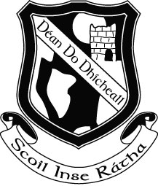

Rang a Cúig – Fifth Class
Book List 2015 - 2016

Religion: Alive O 7 (workbook only)

English: Treasury E – Core Skills in English (Folens)
Pocket English Dictionary and Thesaurus
My Spelling Workbook F (Prim-Ed)

Maths: Time for Tables (EDCO) (Keep this from 4th class)
New Wave Mental Maths (5th Class) Prim-Ed
Figure It Out 5 (CJ Fallon)
Geometry Set

Gaeilge: Sin é 5 – (EDCO)
Litrigh é Linn 5 (EDCO)

Stationery

2 x HB Pencils
10 x 120 Page Copies
2 x Squared Sum Copies
Red & Blue Biros/Pencil/Ruler/Sharpener/Eraser
Pritt Stick x 2
Colouring Pencils
1 A5 Note Book
Mathematical Set

Please note that Book Rental Fees ( €25.00) and Art and Craft/ Photocopying Fees (€10.00) will be due in September, a letter with the details will issue to you in September.

Book List 2 (The following books will be available to rent from the school in September )

Do not buy these books

Rang a Cúig – Fifth Class
Book List 2015 - 2016

Religion: Alive O 7

English: Wonderland: Up and Running
Sourcing Information – A non-fiction Book (EDCO)
The Jazzman
Edge of the Wild
Kensuke’s Kingdom (Class Novel)
Under the Hawthorn Tree

Maths: Mathemagic 5 (CJ Fallon)
Calculator

History: History All Around Me 5 (EDCO)

Geography: Geography All Around Me 5 (EDCO)
Fallons Oxford Practical Atlas

