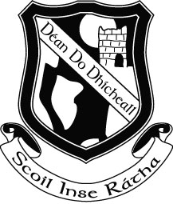

Rang a Trí – Third Class
Book List 2015 - 2016

Religion: Alive O 5 (Workbook only)

English: Treasury C – Core Skills in English (Folens)
Between the Lines 1 (Edco)
My Spelling Workbook D (Prim-Ed)

Maths: Time for Tables (Edco)

Gaeilge: Sin é 3 – (Edco)
Litrigh é Linn 3 (Edco)

Stationery

88 Page copy x 6
100 page notebook
2 Squared Maths Copies (C3 – 7 mm)
2 x Learn to Write B2 Exercise Copies
3 Plastic Document Wallet Folder
2 red biro, 3 blue biro, 2 x HB Pencil/Ruler/Sharpener/Eraser/Long Ruler (30 cm)
Pritt Stick x 2
Colouring Pencils

PLEASE LABEL ALL COPIES AND BOOKS

Please note that Book Rental Fees ( €25.00) and Art and Craft/ Photocopying Fees (€10.00) will be due in September, a letter with the details will issue to you in September.

Book List 2 (The following books will be available to rent from the school in September )

Do not buy these books

Rang a Trí – Third Class
Book List 2015 - 2016

Religion: Alive O 5 (Reading Book)

English: Wonderland: Get Set
Questions and Answers – An information book (Edco)
No Room for an Elephant (Edco)
A Perfect Fit (Edco)
Novel: Fantastic Mr. Fox

Fallons English Dictionary

Maths: Mathemagic 3 (CJ Fallon)

History: History All Around Me 3 (Edco)

Geography: Geography All Around Me 3
Fallons Oxford Practical Altas

