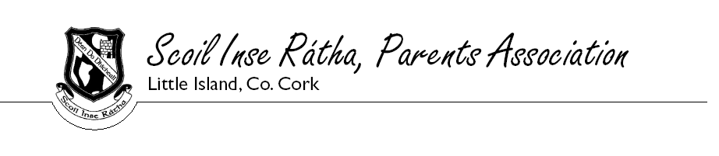
CHRISTMAS 2012 RAFFLE – PRIZE WINNERS

1. €100 FOOD HAMPER SAM RYAN, ST LAPPANS PLACE

2. DVD PLAYER GREG KZEL – SNR INFANTS

3. 4 GREEN FEES FOR CORK GOLF CLUB MISS CASSIDY – LITTLE ISLAND NS

4. AFTERNOON TEA HAYFIELD MANOR PATRYCJA WIERZBILKA, GLANMIRE

5. GREEN FEES FOR COBH GOLF CLUB ANN DALY, THE FAIRWAYS

6. CLONAKILTY PUDDING HAMPER ADAM HARRINGTON – 2ND CLASS

7. 6 BOTTLES OF WINE HENOK ATTIKOSSI – 2ND CLASS

8. BALLYMALOE HAMPER FRANCIS CLARKE

9. SPAR HAMPER LYNETTE FITZGERALD, CARRIGTWOHILL

10. SET OF 2 BOTTLES OF WINE DANIEL FELDMAN – JNR INFANTS

11. SET OF CHRISTMAS LIGHTS MS NEVILLE – LITTLE ISLAND NS

12. BEAUTY HAMPER DAVID FOLASADE – 5TH CLASS

13. FLOWER POWER GLOUNTHAUNE VOUCHER EVIE O’SHEA – JNR INFANTS

14. 2 BOTTLES OF WINE JILL LONG – S ENIOR INFANTS

15. BOX OF DORITOS + 6 BOTTLES PEPSI SCOTT HORGAN, CLASH ROAD

16. BOX OF DORITOS + 6 BOTTLES PEPSI ANGELA AHERNE BALLYTRASNA PARK

17. TOASTER AICYIS WORONOWICZ

18. BEAUTY SPOT GLOUNTHAUNE VOUCHER FAVOUR OMILEKE

19. CLOSE SHAVE BARBERS VOUCHER MONIKA DOBRZANSKA – SNR INFANTS

20. ZEST EAST GATE VOUCHER MAEVE TOMLINS, LITTLE ISLAND NS

Congratulations to all our winners. Thank you for your continued support and wishing you all a very Happy Christmas.

THE PARENTS ASSOCIATION

