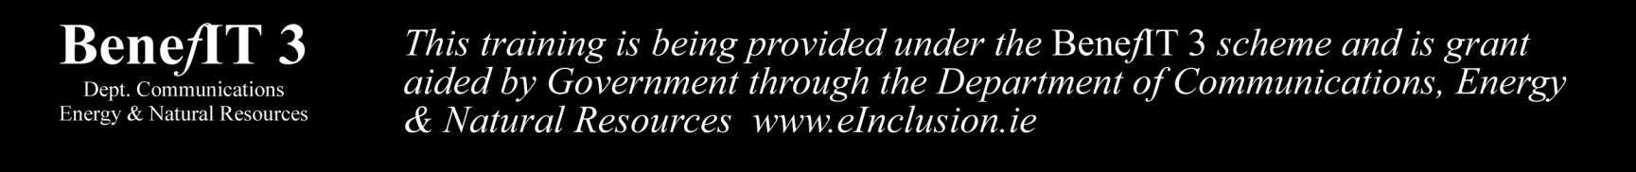

**Learn the basics of Internet Security for the subsidised rate of only €10.**

**Targeted at beginners - no prior knowledge of using a computer/iPad necessary.**

**Course consists of three x 2 hour classes**

**Course Date: Mon 5th Nov. Mon 12th Nov., Mon 19th Nov.**

**Time: 6pm-8pm Location: Room 7 Little Island NS**

**Contact: Michelle Dunne, teacher in Little Island NS.**