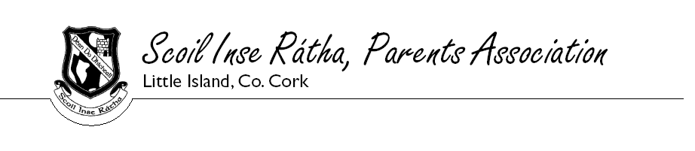
CHRISTMAS 2013 SCHOOL RAFFLE – PRIZE WINNERS

- €100 LUXURY CHRISTMAS HAMPER Sponsored by the Parents Assoc.
KATE MC CARTHY
2. TEETH WHITENING VOUCHER €150 from Smiles & More
LYNETTE FITZGERALD
3. VAX STEAM FLOOR CLEANER from by Harvey Norman
COLIN GURHY
4. 3 MONTHS GYM MEMBERSHIP from the Radisson Hotel
CIAN KIRBY
5. FOURBALL GOLF VOUCHER from Cork Golf Club
UNA O’RIORDAN
- CHRISTMAS FOOD HAMBER from SPAR
ADAM ADAMSKI
- CLONAKILTY HAMPER from Clonakilty Black & White Pudding
LINDA KUZMINA
- INDOOR KARTING FOR 2 VALUE €58 from Kartmania
MARY HORGAN
- 1 MONTH GYM MEMBERSHIP + 2 BOTTLES WINE from Mayfield Leisure Centre
& Cara Partners JACQUELYN AIGBOLOGA
- VOUCHER FOR €25 FROM THE RISING TIDE + 2 BOTTLES OF WINE from Classic Drinks
GEAROID CASHMAN
- €50 VOUCHER FROM CARPETS DIRECT
JAMIE O’DONOVAN
- 2 SETS OF INDOOR/OUTDOOR CHRISTMAS LIGHTS from MK Illuminations
MARY CASHMAN
- GIFT PACK FROM ESB Marina Park Station + SMOKE DETECTOR from Heatmerchants
AIDAN FITZSIMONS
- WASH, CUT & BLOWDRY from Heavenly Hair Glounthaune
JOSEPH OMILKIE
- 5 SPINNING CLASSES from Total Body Training + 2 BOTTLES OF WINE from Fitzpatricks Shop YVONNE HODNETT
- CHOCOLATE GATEAU from Catering Suppliers + 2 BOTTLES OF WINE from Christies Wine
ANGELA C/O ANGIE AGORO 6th CLASS
- TOASTED SANDWICH MAKER from Edmondson EWL + BOTTLE OF WHISKEY from Liam A Barry GILLIAN DIAMOND
- BOX OF DORITOS + 24 CANS OF PEPSI from Pepsi Cola
STEPHEN CLARKE
- WINE GIFT SET from Murrays SuperValu Mayfield + TIN OF BISCUITS from Dessie’s Tyres
LYNN DOYLE
- 2 SETS OF BEER & GLASSES from Kraft Beer Company
ANTHONY DALY
21. PIANO APPRENTICE KEYBOARD from MMD Distribution
LILIANNE AGBOR
22. CAMERA TRIPOD + iPHONE ACCESSORY KIT from MMD Distribution
MARY CLIFFORD

Congratulations to all our winners a big thank you to all the companies who donated prizes for the draw. Sincere thanks for your continued support and wishing you all a very Happy Christmas.

THE PARENTS ASSOCIATION

